GAD132 Readings & Assignments: Week 1
Week 1 Reading
Complete the following reading early in the week:
* Week 1 online lectures.
* The following sections from The Animators Survival Kit: A Manual of Methods, Principles and Formulas:
* Drawing In Time
* Time To Draw
Note: In addition to reading the lectures and assignments for this week, you also need to continue familiarizing yourself with the software required for this course. Spend some time on exploring and experimenting with each feature of the software. This will help you in the later weeks when you have to actually use the software.
Week 1 Assignments Overview
Assignment Summary: WEEK 1 | Due Date
Assignment 1: Autobiography | Friday, August 22, 2008
Assignment 2: Discussion | Friday, August 22, 2008
Assignment 3: Bouncing Ball | Monday, August 25, 2008
Using the navigation on the left, please proceed to the next page.

Course Overview and Welcome
Animation is the representation of life. Movement and life are so closely associated, and it's difficult to imagine life without movement. Since art began, artists have strived to simulate the movements of life in their work. This is evident in the illustrations on cave walls and Egyptian wall decorations, which date back to around 2000 B.C. With animation artists have found a way to instill life into characters and objects.
Today animation is seen in many forms of art, like movies, commercials, or computer games. You may have observed that animation in games is slightly different than that in movies and commercials. There are several reasons for this. This course describes some of these reasons, showing you the basics of creating two-dimensional animation as it relates to the world of gaming.
In order for you to appreciate the process of animation in the industry today, we'll begin with its history and evolution. In a step-by-step manner, the course will help you to understand each stage in the process: sketching, scripting, storyboarding, key framing, and so on, until you are ready to start creating animations using your own story inspirations!
You will create a 12-second animation short, such as a pregame cinematic sequence. Those of you who've played any of the 3D action games, such as American McGee's Alice or Heavy Metal F.A.K.K.2, will know that a prudently tailored pregame cinematic short (which is usually 2D) can greatly enhance the game-playing experience. In order to develop your artistic skills, you need to be constantly sketching from real life. This sketching will help you create effective animation later. Get into the habit of keeping a sketchbook handy and drawing anything interesting that catches your eye. There are no shortcuts to becoming a good artist; you have to sketch, sketch, and sketch!

Learning Outcomes
- Associate historical aspects of 2D animation to current animation styles and processes.
- Recognize and explain the principles of Claymation, cut-out, stop-action, and cel animation.
This doesn’t imply that animation is just drawing a series of motion sketches. There are other aspects you need to understand, such as:
• Creating the plot
• Deciding on characters
• Setting timing for dialogs and action
• Using proper camera angles
• Incorporating phonetics and speech physiology
You’ll learn these skills as you read through different lectures and carry out the corresponding assignments. Your assignments will include several short weekly practical projects and one continuing Final Project to help you experience the actual animation process. The first lecture of next week provides details on the Final Project.
Your facilitator will provide guidance and support to help you complete the projects. As with your previous courses, a discussion forum will give you a chance to exchange ideas and learn from your peers.
You’ll find yourself making dozens of sketches, many of which will be discarded as you finalize your first 12-second animation. Don’t let that extra work discourage you! It will all be extremely worthwhile once you see your characters come to life in front of you!

History of Animation & Types of Animation
Animation has evolved over a number of years, both as an art form and a craft. The idea of animation can be traced back to the time when people lived in caves. The illustrations such as those on the Alta Mira caves walls of Northern Spain show animals with four pairs of legs to depict movement. In Greece, pots were adorned with a series of drawings of a person in motion; when the pot was spun quickly the person appeared to be running. Egyptian wall decorations (2000 B.C.) show movements such as the action of two wrestlers shown in variety of holds. The Japanese also told continuous stories by using scrolls. Years later some of Leonardo Da Vinci's illustrations show the appearance of limbs in different positions.
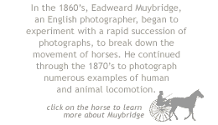
Since animation is about the illusion of motion, it's important to understand the fundamental way in which a human eye perceives an image. In 1824 Peter Rogers presented a paper on the persistence of vision, which noted that the human eye and brain retain a visual impression for about 1/30th of a second (the exact time depends on the brightness of the image.) It "accounts for our failure to notice that a motion picture screen is dark about half the time, and that a television or computer image is just one bright, fast, little dot sweeping the screen" (Extracted from the article "Persistence of Vision"). So when a series of images is moved or flipped fast it looks like a single picture and not distinct images.
This theory of persistence of vision found practical application in a contraption devised by a Frenchman Paul Roget in 1828, called the Thaumatrope. It consisted of a disc with a string on both sides—one side with a drawing of a bird and another with that of a cage. When the disc was twirled fast, the bird appeared to be inside the cage.
The Thaumatrope was followed by several other devices such as the Phenakistoscope, created by Joseph Plateau in the early 1830's; and then the Zoetrope (or the wheel of life), contrived by Pierre Desvignes in 1860. Each device became ever more sophisticated example of the principle of the Persistence of Vision.
From this point on, animators started publishing animation to capture mass attention. Animation made its way into publishing through flip books that became popular in 1868. These books contained a series of images of an object; and when the pages of the book were flipped fast, the object appeared to move. These flip books were the next successful attempt at creating the illusion of motion for an audience.
The motion camera and projector were developed by Thomas A. Edison, and provided the first real practical means of making animation. In 1906 Stuart Blackton released a short film Humorous Phases of Funny Faces, in which he drew comical faces with chalk on a blackboard and photographed them. He then erased the first face and drew another face or facial expression. The movement was achieved by transitioning between the chalk drawings on the blackboard and moving cardboard cutouts of the characters. This gave a "stop motion" animation effect.
In 1908, Emile Cohl made his first film called Fantasmagorie. This film was resplendent with structures such as houses and lampposts that showed emotions. Clearly no director could direct inanimate objects to act; animation provided the means to create fantastic effects that would captivate the audience.
Shortly after the advent of animation films, Winsor McCay applied the flip book idea to animate his comic character, Little Nemo, in a film that was released in New York in 1911. Little Nemo won hearts by the score, leading the way for McCay's future success in the Story of the Mosquito.

In the early 20's the popularity of animation declined because audiences tired of films with rigid character movements and little or no storyline. During this time McCay experimented with the film Gertie the Trained Dinosaur, which combined animation with live action. The audience was amazed when Gertie, an animated character, bent down to pick an apple from McCay's hand. The combination of real action and animation helped the audience relate to the animation in a new way, paving the way for more character animation films.
After the sensational success of Gertie the Trained Dinosaur, animators started creating films that were based on characters that appealed to the audience, such as Pat Sullivan's Felix and Walt Disney's Mickey Mouse. These characters emulated personalities of real-life characters. Steamboat Willie (the film that introduced us to Mickey Mouse) was also a milestone as it was the first film to combine sound with animation
Learn more about Muybridge: http://americanhistory.si.edu/muybridge/
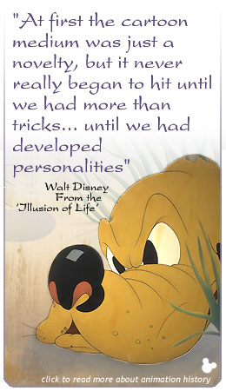
There were more films by Disney that made history, each one in a different way—The Skeleton Dance was an example of the way sound can be synchronized with action; Flowers and Trees used technicolor for the first time; The Three Little Pigs and Snow White and the Seven Dwarfs were the first feature-length animation movies.
Another venture, this time by the Warner Brothers Studios, started off with the musical series Looney Tunes and Merrie Melodies; these were followed by the Porky Pig cartoons. Some of the significant characters of the Warner Studios are Bugs Bunny, Daffy Duck, Sylvester the Cat, and Tweety. The Warner Brothers Studio stayed in the animation business for over 20 years, creating characters we still love today.
With the advent of Xerox and the copying process, the cel animation process encountered major changes. Years later, the emergence of computers created another enormous change in the animation business. The majority of the time-consuming processes such as the use of camera, inking and painting, and sound synchronization with animations, became much easier and much more cost effective.
Gradually computer-based techniques started making their way into the world of animation, giving way to sophisticated and higher-quality animations. Besides movies, animation entered the world of computer games. Today various genres of computer games crowd the market with different types of animations.
As you progress through the course you'll learn how 2D animations are applied to gaming. You'll also need to research games to look for the types of animations used in them.
Learn more about the origins of American Animation:
http://memory.loc.gov/ammem/oahtml/oahome.html

Cel Animation Process
Animation involves much more than creating simple drawings. When animating a sequence you need to go through a certain set of procedures. Just as in baking you need to mix the ingredients in the right proportion and follow the right sequence, while creating an animation sequence you need to follow some logical steps. Many employers state that the primary skill that they look for is an artist's ability to understand and articulate the process of creating animation. The concept of process includes the why of creation as opposed to the how.
One of the oldest process of animation is the cel animation process. The term "cel" originates from the word celluloid, which is a transparent sheet of material. In much the same way as you would composite a frame in different layers using Premier or Photoshop, these transparent sheets acted as different layers to develop the image. If you examine such cel process cartoons as The Flintstones you can see strong lines between the torso and head, arms, legs, etc., of the characters. This was to help put together the different layers of transparent sheets. There could be many sheets used to create a single scene in the same way as you could use many layers to create a single image in Photoshop.
With the advent of computers cel animation has undergone changes at various stages, but the basic process still remains the same. This lecture takes you through the traditional cel animation process highlighting those steps used to create an animation.
There are three major phases in the process of cel animation:
1. Preproduction phase
2. Production phase
3. Postproduction phase
In the following segments we'll take a quick look at the components of each of these phases.
Preproduction Phase
As the name suggests, this phase helps you plan and prepare for the complete animation. While planning, you might discover and fix problems before they become serious. This saves time and reduces rework in the later stage. The preproduction phase consists of the following activities.
Scripting
Animation starts with an idea or a concept, based on which a script is written. A script, first and foremost, is a story that contains the details of the character and layout that make an interesting animation sequence. These details are then developed into structures such as character designs and storyboard.
Storyboarding
A storyboard consists of a series of visuals used to narrate the story in the planned sequence. It also contains specifics about the environment and location in which the characters will play their parts, and the camera angles for each scene. Most storyboards contain dialogs and descriptions of sound effects to better aid narration.

Thumbnailing
Rough drawings of characters, objects, or scenery, are called thumbnails. These are created at various stages of the preproduction phase, for the reference and understanding of the animator, to provide a rough idea of an intended layout. Thumbnails are like instant lead-ins that channel a view into the storywriter's perspective of a character or a scene.
At the scripting stage thumbnails can be created to demonstrate specific details of a character, such as a huge pot belly or intensely droopy eyes (like that of Garfield), or scenery such as a dockyard at a distance behind the protagonist's residence. At the layout stage thumbnails can be created to provide multiple perspectives of a scene, the best of which is chosen later. Thumbnails also work as time savers to plan the staging of an action.
Character designing
Character designing establishes the personality and purpose of a character. At first, characters should be simple. After a personality is assigned to a character, different poses and gestures can be created that match the personality. The actions, feelings, and expressions of the character, captured from different angles, are drawn in separate sheets called model sheets.
Explore: The thumbnail sketch - http://mag.awn.com/index.php3?ltype=cat&category1=Tutorials&article_no=274
Production Phase
The actual development of an animation starts in the production phase, after the storyboard is approved by the team. A typical development team consists of a director, a specific set of artists for each stage of production, and the animators.
The production phase consists of the following activities:
Creating X-Sheets
An X-Sheet (or an exposure sheet, or “dope sheet”) provides the detailed description of the various actions, the time taken for each action, and various layers of background in a scene. The timing of an X-Sheet should correspond with that of the sound track and camera instructions.
http://www.animationpost.co.uk/doping/dope-intro.htm
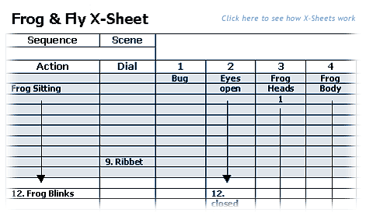

Designing layouts
Before creating animation sketches, you need to design the location and scenery that will form the background for the story. The key positions of your characters, their movements, and their actions are also decided at this stage. Layouts contain different camera angles and shots that add interest to a story.
Creating key sketches
In this step a series of rough drawings that depict the movements of characters are made. These are called key drawings and correspond to particular scenes of the storyboard. You start by drawing the two positions—called extreme positions—that illustrate the beginning and end of a character's movement, then create keys drawings to show the transitions in between.
Let's look at an example to understand this. Suppose you have to animate the opening of a fist. The extreme position drawings will be a closed fist and an open palm. The key drawings will involve the successive positions of the hand between the fist and the palm.
Pencil testing or Line testing
Pencil testing involves photographing or scanning the rough drawings with the help of a web camera or a scanner, and playing these drawings in an editing program such as Adobe Premiere, Adobe After Effects, or Firka. When you do a pencil test, timing and movement in animation are tested repeatedly.
Cleaning up
After pencil testing the rough key drawings and fixing problems, you need to clean up the rough key drawings to capture the fine details specified in the model sheets. Use fine and clean lines to develop the physical appearance of a character. However the movement and flow of an action in the animation should not be lost during this process. Note that a good animation can be ruined by errors in cleaning. It is therefore important to identify the action lines (you'll learn about this in the next week) in the sequence, and clean up drawings carefully.
Once again the emphasis is on strong drawing, where the quality of lines, whether thick or thin or overlapping, need to be perfected.
Inbetweening
Adding final action drawings in between the key drawings creates smooth movements. This process is called inbetweening, and the drawings are called inbetweens. How many of the fine drawings are added between the key drawings is based on the timing of the animation and the movement required.
Production Phase
After the sketching activity is complete and the sketches are cleaned, it's time for compiling the scenes together to create the sequence. From this point on the animation process is digitized.

Scanning
The animation with the inbetweens is now ready to be scanned in the sequence given by the artist, so that the continuity of the action is maintained. In this process, you adjust the brightness, hue, and other details so that the pencil lines become sharper. Specialized software such as US Animation, Cambridge Animo, Rita's Pro, Media Pegs, CTP Pro, AXA, and Flip Book Digicel are designed for this purpose.
Note that before the advent of computers, all the drawings were photocopied on the cels, manually colored, and then captured on a tape using camera.
Coloring (Ink and Paint)
The scanned sketches are then numbered according to the sequence in the X-Sheets. Each part of the sketch, backgrounds and locations, is colored in a specific color, using software such as Photoshop and Painter. Again, before computers came on the scene, this was a very-time consuming process because each cel had to be colored manually using ink and paint and brushes, as suggested by the name of the process.
Compositing
In compositing different layers of background, positions of characters, and camera moves are compiled on one platform. X-Sheets are the most important reference guides for this phase. Once the compositing is finalized, the scenes are rendered for video transfer.
Post-production Phase
The two main activities involved in the post-production phase are editing and adding sound. An edit check is run to see if the scenes are falling into the required sequence. Once this is confirmed, the rendered footage of the animation is combined with a prerecorded sound track and a music score. For this, the X-Sheets and the storyboard are used in conjunction.

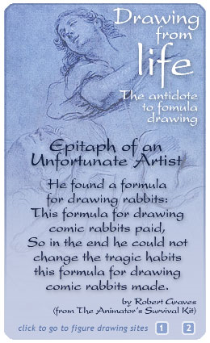
Movement & Drawing from Life (An Observation Exercise)
To be a good animator you need to draw well and draw quickly. Learning to animate without learning to draw is like trying to write sentences without knowing the alphabet or grammar! Though computers have simplified the production process of animations, they're no alternative to creative thinking and rendering skills! Before you start any sketching activity, let's quickly recap the requisites for becoming a good animator:
Observing life
The best way to become a good animator is to observe and draw life forms, objects, and movements around you. To begin with, sketch the scene outside your window or ask a friend to pose for your sketch.
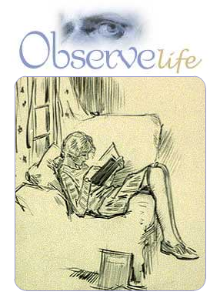
Understanding anatomy
Even in cartooning, because cartoons are exaggerations of life forms, you need to know the correct proportions of a living form first. This knowledge will help you make an informed choice of what you want to modify in the object or figure you're drawing.
Understanding the subject and situation
To be a successful animator, you must peek into your character's mind. If you are planning to animate a lost puppy, it's a great idea to shut yourself in a room, imagine that you are the poor little lost puppy, and act out a scene. A mirror will definitely add an interesting perspective.
Capturing intent: It is more significant to capture the intent of a situation rather than capturing all the little details about the characters. An angry man is drawn with frowning eyebrows and narrowed eyes, whether he is the villain or the hero! To depict a strong man, we emphasize his muscles in the drawings, while to show a man in hurry, we focus our efforts on his body language and facial expressions. Whether the man is muscular or lean, the body language of a man in such a situation remains the same.
When you are drawing for animation, unnecessary details in the first sketch will make it difficult to control the movement in the successive sketches. So to preserve the accuracy of the action you're trying to capture, you must draw at different levels of detail.

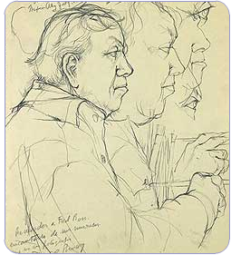
Drawing action poses or gestures is like acting on paper. If you are drawing the parts of a body such as an arm, a torso, or a leg, you're drawing "stills," but if you're drawing an arm stretching, a torso twisting, or a leg bending, you're drawing actions, motive, and story! So when drawing for animation, suggest all the physical manipulation it takes to express or verbalize the action.
You will be required each week to do life study sketches and post them to the discussion board. Take the time to critique each others drawings and offer suggestions and comments. Your facilitator will assist you as well in developing your skills and visual interpretation of movement. Note: If you wish to learn more about creating realistic life drawings, you may refer to Vilppu Drawing Manual by Glenn Vilppu and Words of Wisdom by Walt Stanchfield.
Proportions of Human Figure:
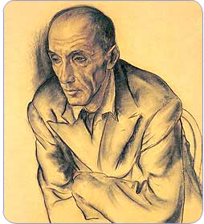
http://drawsketch.about.com/cs/figuredrawing/a/fig_proportion.htm?terms=figure+drawing
Sketching and Location: Drawing Groups of figures
http://mag.awn.com/index.php?ltype=Columns&column=vilppu&article_no=160

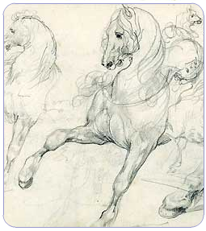

The Principles of Animation
The ingredients of all successful animations, whether 2D or 3D, are a combination of twelve basic principles. These are:
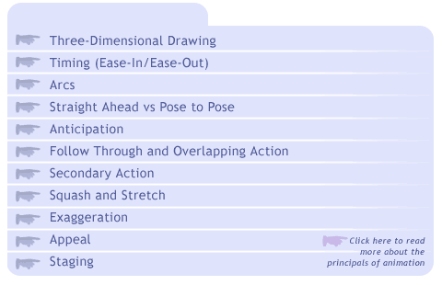
Learn more: http://genedeitch.awn.com/index.php3?ltype=chapter&chapter=4&page=1
Three-Dimensional Drawing
As stated in The Illusion of Life by Frank Thomas and Ollie Johnson, one of the signboards in Disney Studio said: "Does your drawing have weight, depth, and balance?" These are the three basic characteristics of a three-dimensional object. The third dimension in the context of sketches means creating an illusion of depth in them. The sketches should clearly demonstrate mass, volume, and weight of a character. This is also called "solid drawing."
To use a familiar example imagine the movements of a half-filled flour sack, try to sketch them, and you'll find yourself concentrating on the weight, volume, and displaced mass of the sack in each sketch.
To create active postures, such as walking, remember that the legs must bend to indicate weight displacement.
Timing
Readability of an idea depends on good timing. Enough time should be spent preparing the audience for an action, then on the action itself, and finally on the reaction to the action. If too much time is spent on any one of these, the timing will be too slow and the audience will be distracted. If too little time is spent on any part of the preparation, the idea won't register with the audience.
Consider a chase between two birds: an eagle chasing a sparrow. The timing for both the moves has to be such that even with its rapid wing movements the sparrow covers only half the distance of the eagle, which catches up in slow and steady wing strokes.
Objects with greater mass have slower movements than those with smaller mass; King Kong will walk more slowly because of his bulk than little girl following him. In the words of Chuck Jones, the director of Bugs Bunny and Daffy Duck, "The difference between the right timing and the almost right timing, is the difference between lightning and a lightning bug."
(Bouncing Ball Example)
The concept of timing comes into focus right from the sketching stage. If it's the swings of a pendulum, decide on its speed and then, depending on the speed, draw the key poses. The slower the movement, the more poses need to be added.
It requires a lot of practice to perfect the timing for an action. Every object has unique weight, construction, and degree of flexibility and therefore behaves in a unique way when a force acts on it. The result of a force on an object with respect to time needs to be determined. Answers to questions such as How long does a door take to slam? or How fast does a cloud drift across the sky? should be clear to an animator. It is also necessary to be aware of the time it takes for the average person to assimilate an idea.
Timing: Ease-In/Ease-Out
Only a few objects in the real world move at a constant speed. Imagine a car beginning to move. It starts slowly, gains speed, and then moves at a constant speed for some time. Suppose there's a patch of oil on the road; the car starts skidding, gains speed, and then slows down again until it reaches the normal speed and so on. This increase and decrease in the speed of a moving object is commonly referred to as "ease-in" and "ease-out." You can achieve realistic motion by adding ease-in and ease-out to a moving object.
When drawing action sequences remember that the closer the subsequent sketches the slower the intended action is, and vice versa. Look around and observe various movements; try to note the timing for each. When you sketch these movements, consider the number of "inbetweens" you'll have to add to replicate the exact timing.
Arcs
An interesting phenomenon to note in animation is the formation of arcs. If you can track the motion of an arm serving a tennis ball, a head turning from left to right, and a ball bouncing on the floor, you'll find that each object forms an arc along its path.
Now try to move your head from left to right in a straight line to avoid an arc formation. What do you notice? In the absence of arcs the movement of an object becomes stiff and mechanical. This is an important guideline for an inbetween artist. While creating inbetweens the path of motion should maintain the natural arc. Remember the statement by Frank Thomas and Ollie Johnson, "Drawings made as straight inbetweens completely kill the essence of the action."
Straight Ahead and Pose-to-Pose
These are the two kinds of processes followed by the artists to depict a character in action: straight ahead and pose-to-pose. In the straight ahead method the artist draws each subsequent pose of a character, starting with the first. For example to show a character diving into a swimming pool from the diving board, the artist can think of taking a straight ahead approach. The transition from one pose to the other will be smooth, and the sequence will reveal a predetermined plan. But there's always the chance that the outcome won't be exactly as planned, and that some part of the sequence must be redone from the middle. The straight ahead method is a good plan to take when you're beginning to create animation sketches for the first time.
In the pose-to-pose action the artist draws the main poses first and then the intervening ones. Using this strategy, the individual poses can be established properly and there's clarity of action. Pose-to-pose is useful when showing quick transitions in the sequence of a character's movement. However, the whole sequence of events needs to be planned in advance.
To understand the pose-to-pose approach, let's consider this situation. A character flying in a hot air balloon suddenly falls out, lands on a tree branch, and slips off to land on top of a speeding car! The main poses of the character—flying through the air, stuck on the tree branch, and landing atop the car—will be drawn first. The inbetween poses will be drawn later in keeping with the main poses.

Anticipation
A small sequence of action preceding the primary action is called anticipation. You may have noted that a person leans slightly forward before standing up, an athlete bends his knees before taking a jump, and a cat squats down before leaping at its prey. Leaning, bending, and squatting are some examples of anticipation that precede the primary actions, standing, jumping, and leaping respectively.
In real life anticipation happens before all actions and is so natural and short-lived that we tend to overlook it as separate from the primary action! To create predictable action an animator needs to introduce anticipation.
The amount of anticipation considerably affects the speed of the action following it. It also increases apprehension of the audience about the primary movement and involves them in the action. A properly timed anticipation leads to better acceptance of an action. For instance to show a character zooming past the screen, the animator shows one frame in which the character is leaning back in preparation, followed by one or two frames showing the beginning of the forward movement. A few speed lines or a puff of dust are then shown to imply that the character has sped away. Anticipation is particularly important with fast movements.
Sometimes in animations a few surprise moves called "gags" are incorporated to increase the thrill of a situation, but the number of occurrences should be limited. In others anticipation should follow a normal, predictable action.
Follow Through and Overlapping Action
Every action is made up of three components: anticipation, the actual action, and a follow through. The actions that happen after a primary action is over are called follow through actions. When a person running suddenly stops, different parts of his body come to rest at different times. The legs stop suddenly, but the upper part of the body sways a little forward followed by the hands. All these little actions are part of the follow through action.
In animation a time lag is usually given between the movements of different parts of a body. The movements during the transition of one action pose into another are called overlapping actions. Artists introduce overlapping action to highlight smooth transitions in actions. In a slow, gentle action such as a walk, this may not be necessary, but in a more aggressive action such as bowling, overlapping action provides fluidity.
Secondary Action
The action that follows a primary action is called a secondary action. The movement of the shoulder following the turning of the head, the wagging tail of a dog following its body, and the flapping of a coat tail behind someone walking are a few examples of secondary action.
Secondary action may or may not happen in the same body; this feature distinguishes secondary action from follow through. However, secondary action usually happens in the opposite direction to the primary action. This helps to maintain the balance of a moving body.
The object that is affected by the secondary action is called an "accessory" or "extremity." The movement of an extremity depends primarily on:
- The force and timing of the primary action
- The extremity's own weight and degree of flexibility
- Air resistance

Squash and Stretch
The squashing and stretching of forms is another basic principle seen in nature. If you closely observe a bouncing rubber ball, you'll find that the ball squashes a bit on hitting the ground and then stretches back to its original shape on bouncing up again. Squash and stretch can be observed when a flexible object comes in contact with another object. Some examples of squash and stretch in real life can be seen in the leg muscles of a walking character, the hands, body, and neck of a jumping boy, and so on. Only rigid objects such as a brick wall or glass do not squash and stretch.
Squash and stretch is frequently used in creating facial expressions of a character and lip syncing. Look in a mirror and you'll see exactly what feature stretches and squashes when you create a particular expression.
Explore:
How to draw expressions - http://mag.awn.com/index.php3?ltype=pageone&article_no=1405
How to draw facial wrinkles: http://mag.awn.com/index.php3?ltype=pageone&article_no=1412
Note : While showing squash and stretch of an object remember that the volume of the object should remain constant.
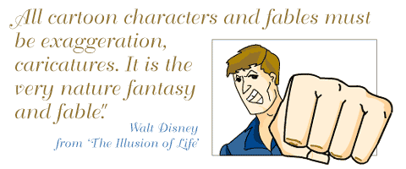
Exaggeration
Exaggeration means creating caricatures of real people or animals. Artists accomplish this by accentuating one particular trait or action of a character. Some examples of exaggerated traits are wide lips for a laughing character or droopy eyes for a perpetually sleepy character such as Garfield. Exaggerated action can be shown by zooming in on the face of a character—think of how you would zoom in on a boss with his mouth wide open, shouting at an employee.
Exaggeration is the most exploited principle in humorous productions. One example is the popular television series Tom and Jerry. Tom, the main character of the series, changes shape whenever he runs into anything; he flattens out like a poster when he hits the wall and then slides down to the floor like a carpet before regaining his original shape. Exaggeration evokes humor and enhances entertainment, in addition to establishing the intended message in a convincing manner. It is a good way of highlighting the otherwise overlooked subtle details of a character. However artists must think about how much to exaggerate; excessive exaggeration leads to unrealistic characters.
Appeal
To understand appeal let's start by answering a few questions. Why are characters such as Mickey Mouse, Donald Duck, and Tom and Jerry more popular than any animated characters? Why do these characters exist as icons in the minds of viewers, years after a television series has ended? The answer lies in the charisma and magnetism of their designs.
Appeal is about the details in personality that draws people to a character. One of the most successful features is the simplicity or realism of design, such as that of Mickey Mouse. In the words of Walt Disney, "When people laugh at Mickey Mouse, it's because he's so human; and that is the secret of his popularity." Other details are expressive features, the poses and postures such as those of Donald Duck, or a particular style of movement. Remember, however, that overdoing the details of a character does not make the character impressive.
Appeal involves exploring deep into the character to bring out the essence of his personality. It's not about creating a hero or villain; otherwise characters like Jafar, villain of Disney's Aladdin, could not have been so popular!
Staging
Staging is clearly communicating the intent of an artist through the poses and expressions of a character. It involves the best way to present the idea of an action. Once the basic poses are right, the artist can proceed with adding appeal or exaggeration to the character. Therefore the idea of staging starts in the sketching stage.
Recall that at the beginning of a production a model sheet is created to illustrate the action poses of a character. The best poses from this sheet are staged for the whole team to look at. Sometimes silhouetted thumbnails of these poses are drawn to see if the action can be universally identified. A consensus on this is required before the production begins.
Staging in animation means setting the perfect time and location for an action so that the audience is able to register the action. Too much movement can spoil the spirit of the action; remember the theory of persistence of vision.
Camera work also plays a vital role in staging. Proper mood of a scene can be established only through proper camera angles.
Staging, like timing, is another principle that can be perfected with years of practice. Improper staging can mar nicely designed characters or a great script!
This brings us to the end of the animation principles. From here on remember to relate any animation you watch or create to these principles. Observe the principles that are used most and look for the typical combinations.
The Bouncing Ball
With the principles of animation in view, let's discuss their application in a few real-life objects. The idea is to see the combination of principles in animated objects.
Observing Real-life Motion
An animator learns to create realistic motion with a time-honored exercise. So to animate, start by observing real-life objects in motion. Drop a rubber ball onto a hard horizontal surface and see what happens. From its highest point the ball falls to the ground, then with each bounce the ball loses height until it finally comes to a stop.
If you analyze this motion, you notice that the ball bounces along a semicircular path, an arc called the "path of action". The trick is to make sure your animated ball always stays on that line of arc or the animation will look wobbly.
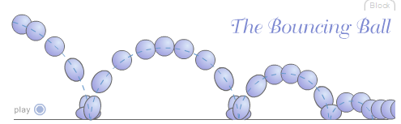

Drawing and Animating
Start drawing the path of action of the bouncing ball; the arcs touch the horizontal surface on impact. Keep reducing the size and height of the arc in subsequent bounces.
Next identify the positions of key drawings on the arc. These positions define the placement of the ball and help determine the timing of the animation. When the ball is at the peak of the arc, the speed reduces and so the sketches of the ball should be placed close to each other. When animating, an ease-in needs to be applied at this position. Similarly create sketches of the ball further apart from each other when the ball comes down the arc and bounces up after the impact. Remember to apply ease-out at these positions.
You've learned that the ball squashes a bit on impact with a hard surface; you have to slightly flatten the shape of the ball from round to oval when it hits the surface. As it bounces up, it gradually stretches back to its original shape.
Adding Effects
To add some interest in the animation, introduce anticipation. Start altering the shape of the ball to oval when it is just about to touch the ground. This will eliminate the suddenness of seeing a flattened ball on its impact with the ground.
That concludes our discussion on the principles of animation. How will you represent the difference between the weight of an iron ball, a rubber ball, and a ping-pong ball? Think this over, and read on.

Assignment 1: Autobiography
By Friday, August 22, 2008, post a brief autobiography of yourself. Since you are studying art let's try to do something creative rather than only jotting down a simple autobiography. Try to picture yourself in your favorite clothes, and in one of your characteristic moods; sketch, scan, and submit your sketch and autobiography to this Discussion Area. Include the following details:
* Name
* Areas of interest
* Your reasons for taking this course
* Favorite computer games
* What is the all-time-best animated character in your opinion and why?
Review and comment on the biographies of other students by the end of the week.
Assignment 1 Grading Criteria: | Maximum Points
Used correct spelling and grammar in profile. | 4
Provided a personal sketch. | 4
Listed favorite computer games and favorite animated character. | 8
Participated in the class discussion. | 8
Total: | 24
For assistance with any problems you may have when completing this
Assignment 2 – Discussion questions
Discusion Question 2
We have seen the movie and the game industry undergo a tremendous change in the past decade. Newer and more sophisticated technologies are introduced every year. Do you think that traditional 2D animation will disappear from the entertainment industry after a few decades and interactive production will take over? Or do you think 2D animation will hold its ground? Discuss by giving suitable reasons for your point of view.

Discussion Question 4
Going by the fact that observation is the key quality of an artist, what aspects of the real life need to be observed in order to replicate them in sketches? And why do you think these aspects are important?

Assignment 3: Follow the Bouncing Ball
Using the cell production method as described in this week's lecture, create an animation of a bouncing ball using animation software such as Painter or Flash by Monday, August 25, 2008. The ball should have at least 3 bounces and should demonstrate at least 3 of the principles of animation. Post your animation in Quicktime format to the W1: Assignment 3 Dropbox and provide a link to the finished file.
Comment on at least two of your classmates animations, discussing the animation principles and giving suggestions for improvement by the end of the week
Assignment 3 Grading Criteria | Maximum Points
Created a bouncing ball animation with 3 bounces. | 12
Illustrated 3 of the principles of animation. | 10
Responded to 2 other animation projects. | 5
Actively participated in discussing the principles of animation illustrated in the project. | 5
Total: | 32
For assistance with any problems you may have when completing this assignment—OR—to offer your assistance to classmates, please use the Problems and Solutions Discussion area located through the left side navigation link.

